UNIX and 'UNIX−like' operating systems (such as Linux) consist of a kernel and some system programs.There are also some application programs for doing work. The kernel is the heart of the operating system. Infact, it is often mistakenly considered to be the operating system itself, but it is not. An operating systemprovides provides many more services than a plain kernel.

Kernel keeps track of files on the disk, starts programs and runs them concurrently, assigns memory and other resources to various processes, receives packets from and sends packets to the network, and so on. The kernel does very little by itself, but it provides tools with which all services can be built. It also prevents anyone from accessing the hardware directly, forcing everyone to use the tools it provides. This way the kernel provides some protection for users from each other. The tools provided by the kernel are used via system calls

The system programs use the tools provided by the kernel to implement the various services required from an operating system. System programs, and all other programs, run `on top of the kernel', in what is called the user mode

**Interpreter** translates just one statement of the program at a time into machine code. **Compiler** scans the entire program **and** translates the whole of it into machine code at once.

most important parts of the kernel (nothing else works without them) are memory managementand process management. Memory management takes care of assigning memory areas and swap space areasto processes, parts of the kernel, and for the buffer cache. Process management creates processes, andimplements multitasking by switching the active process on the processor.

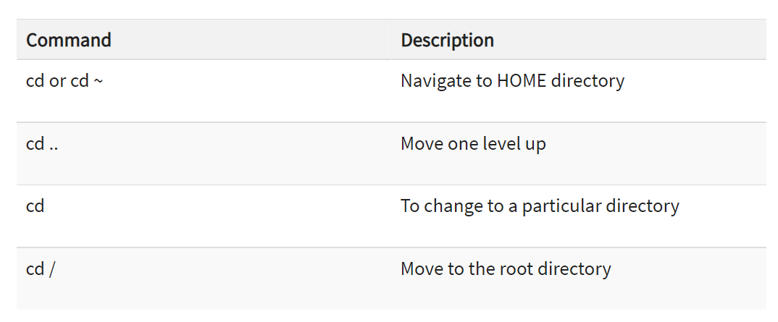

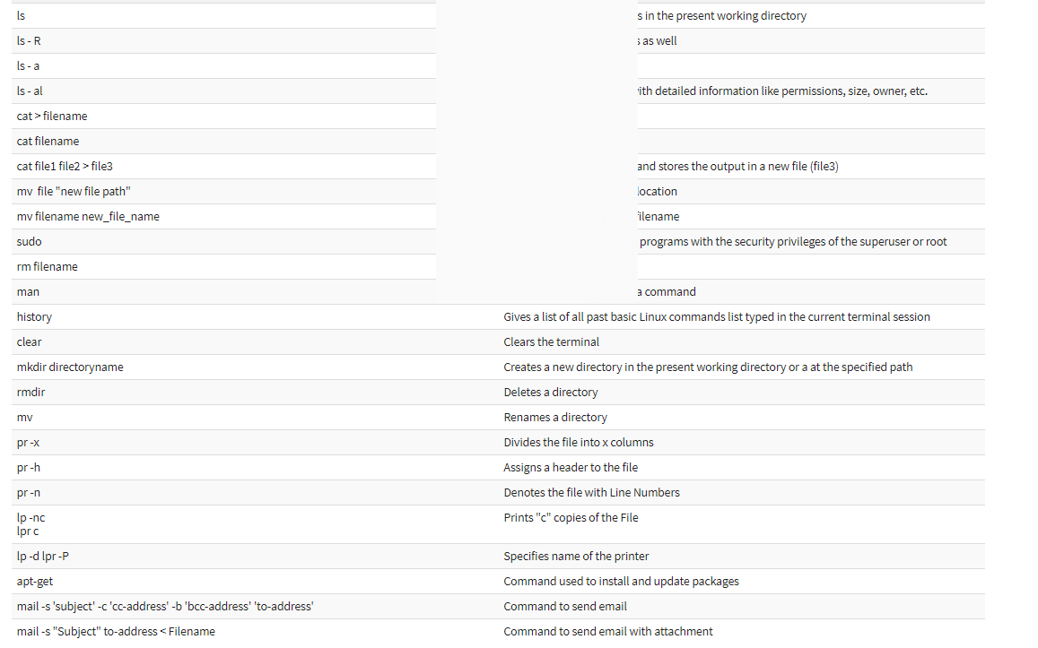

Ownership of linux file:-

User-group-others -rw-rw-r

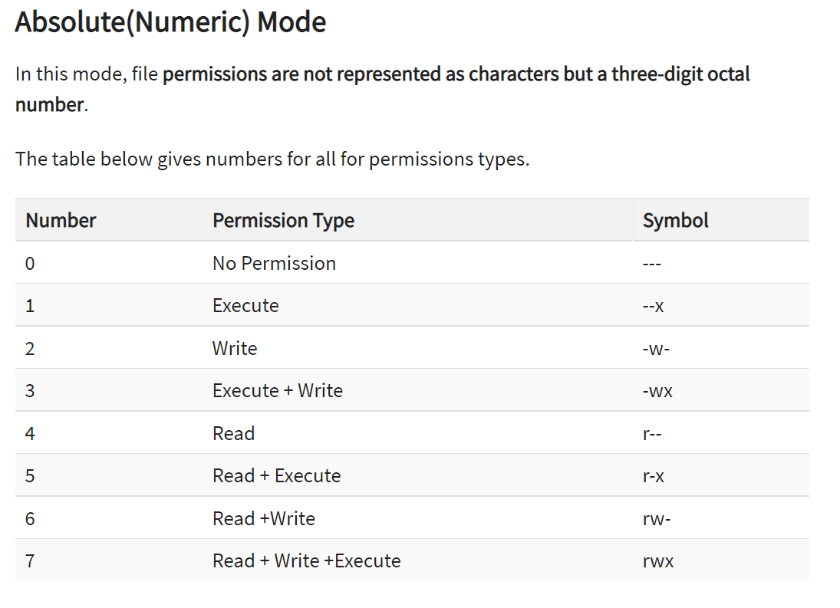

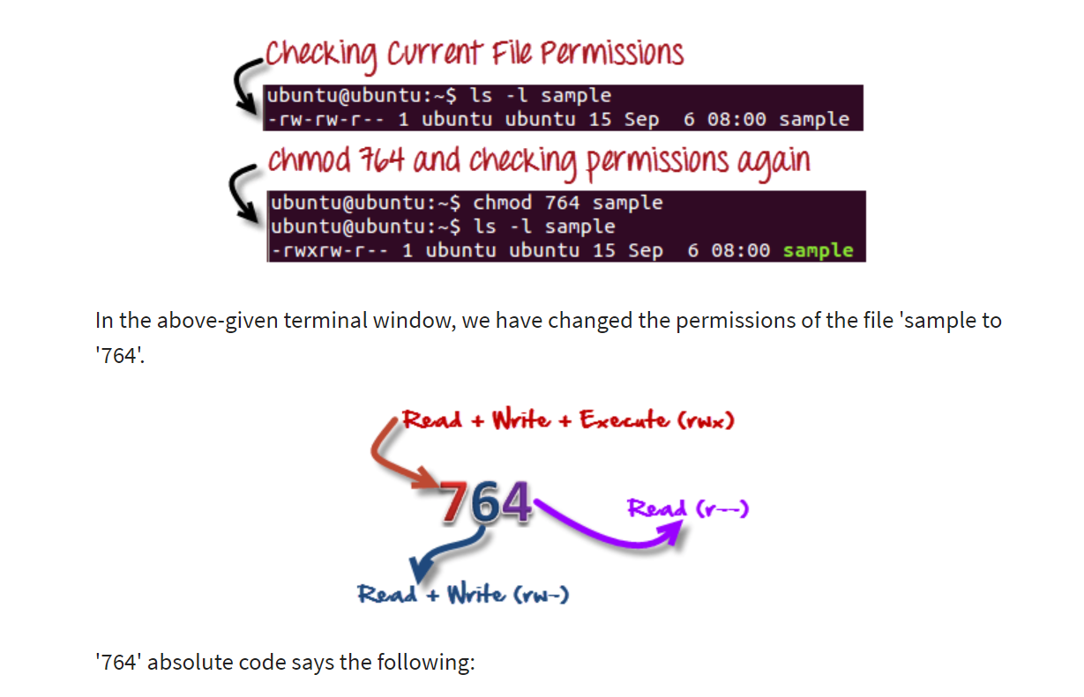

**Symbolic Mode**

In the Absolute mode, you change permissions for all 3 owners. In the symbolic mode, you can modify permissions of a specific owner. It makes use of mathematical symbols to modify the Unix file permissions.

|  |  |
| --- | --- |
| **Operator** | **Description** |
| **+** | Adds a permission to a file or directory |
| **-** | Removes the permission |
| **=** | Sets the permission and overrides the permissions set earlier. |

|  |  |
| --- | --- |
| **User Denotations** | |
| u | user/owner |
| g | group |
| o | other |
| a | all |

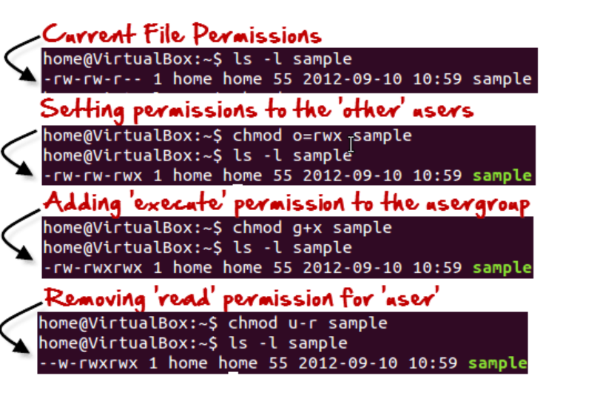

For changing the ownership of a file/directory, you can use the following command:

chown user

In case you want to change the user as well as group for a file or directory use the command

chown user:group filename

## Summary:

* Linux being a multi-user system uses permissions and ownership for security.
* There are three user types on a Linux system viz. User, Group and Other
* Linux divides the file permissions into read, write and execute denoted by r,w, and x
* The permissions on a file can be changed by 'chmod' command which can be further divided into Absolute and Symbolic mode
* The 'chown' command can change the ownership of a file/directory. Use the following commands: chown user file or chown user:group file
* The 'chgrp' command can change the group ownership **chrgrp group filename**
* What does x - eXecuting a directory mean? A: Being allowed to "enter" a dir and gain possible access to sub-dirs.